

**Tribhuvan University Faculty of Humanities and Social Science**

**Online News Portal**

**A PROJECT REPORT**

**Submitted to**

**Department of Computer Application**

**Birendra Multiple Campus**

***In partial fulfillment of the requirements for the Bachelors in Computer*** ***Application***

**Submitted by**

Name: Prameshwor Dharel

Roll no: 28

Name: Safal Adhikari

Roll no:17

14th Jestha 2079

Under the Supervision of **Narayan Prasad Dahal**



**Tribhuvan University**

**Faculty of Humanities and Social Science**

**Birendra Multiple Campus**

**Supervisor’s Recommendation**

I hereby recommend that this project prepared under my supervision by Prameshwor Dharel and Safal Adhikari entitled “Online News Portal**”** in partial fulfillment of the requirements for the degree of Bachelor of Computer Application is recommeded for the final evaluation.

…………………………..

**SIGNATURE**

Narayan Prasad Dahal

Lecturer

Department of Computer Application

Faculty of Humanities and Social Science

Bharatpur-10, Chitwan



**Tribhuvan University Faculty of Humanities and Social Science**

**Birendra Multiple Campus**

**LETTER OF APPROVAL**

This is to certify that this project prepared by Prameshwor Dharel and Safal Adhikari entitled “**Online News Portal”** in partial fulfillment of the requirements for the degree of Bachelor in Compuer Application has been evaluated. In our opinion it is satisfactory in the scope and quality as a project for the required degree.

|  |  |
| --- | --- |
| ---------------------------------------------------  **SIGNATURE of Supervisor**    Narayan Prasad Dahal  Lecturer  Department of Computer Application  Faculty of Humanities and Social Science  Bharatpur-10, Chitwan | ------------------------------------------  **SIGNATURE of HOD/ Coordinator**    Shoba Raj Paudel  HOD  Department of Computer Application  Faculty of Humanities and Social Science  Bharatpur-10, Chitwan |
| **SIGNATURE of Internal Examinar**  **---------------------------------------------** | **SIGNATURE of External Examinar**    **-----------------------------------------** |

Abstract

This is a project of online news portal which is a complete website that allows user to get update on latest news using a phone or a computer with any web browser. It allows every user to get update on recent news as there like. User can create his/her account to make a personalized account for themselves by signing up and creating account. The key focus of this project is to make news available everywhere, anytime for anybody who wants to read news.

Acknowledgement

With much delight, we’d want to express our gratitude to Tribhuvan University Gratitude giving us the chance to write this project report named ‘Online News portal’.

It brings us great pleasure to express our heartfelt appreciation to Birendra Multiple Campus thanks for the chance and advice. Our supervisor is someone we admire and appreciate **Mr. Narayan prasad Dahal** without his intellectual advice and ideas, the study would have been nearly impossible. Their trust in and support for this project report has made this extremely difficult and time-consuming task quite satisfying. We were able to examine our theoretical comprehension, practical knowledge, and abilities of the subject matter as a result of the project. We are heartfelt gratitude to everyone of our friends, family, and teachers who bravely expressed their opinions and assisted us in improving this project. In addition, we would like to extend our deepest gratitude to all those who have directly or indirectly guided me in the completion of this project.

Thank You.

Table of Contents

Chapter 1 Introduction 1

1.1 Introduction 1

1.2 Problem Statement 1

1.3 Objectives 1

1.4 Scope and Limitation 2

1.5 Report Organization 2

Chapter 2 Background Study and Literature Review 3

2.1 Background Study 3

2.2 Literature Review 3

Chapter 3 System Analysis and Design 4

3.1 System Analysis 4

3.1.1 Requirement Analysis 4

3.1.2 Feasibility Analysis 5

3.1.3 Data Modelling (ER-Diagram) 6

3.1.4 Process Modelling (DFD) 6

3.2 System Design 8

3.2.1 Architectural Design 8

3.2.2 Database schema design 9

3.2.3 Interface Design 10

Chapter 4 Implementation and Testing 20

4.1 Implementation 20

4.1.1 Tools Used 20

Xampp Server: 20

PHP: 20

MySQL 20

HTML & CSS 20

JavaScript: 20

Online editor tools: 20

4.1.2 Implementation Details of Modules 20

4.2 Testing 21

4.2.1 Test case for unit testing 21

4.2.2 Test case for system testing 21

Chapter 5 Conclusion and Future Recommendations 25

5.1 Lesson Learnt / Outcome 25

5.2 Conclusion 25

5.3 Future Recommendations 25

List of Abbriviations

• HTML : Hypertext markup language

• CSS : Cascading Style Sheet

• PHP : Hypertext Preprocessor

• DFD : Data Flow Diagram

• ER : Entity Relationship

List of Figures

Figure 3‑1 Waterfall model 4

Figure 3‑2 ER diagram of online news portal 6

Figure 3‑3 Zero Level DFD of Online news portal 6

Figure 3‑4 One level DFD of Online news portal 7

Figure 3‑5 Two level DFD of Online news portal 7

Figure 3‑6 Use case Diagram of Online news portal 8

Figure 3‑7 Architecture design of Online news portal 8

Figure 3‑8 Home Page 10

Figure 3‑9 Search Bar and Recent post 11

Figure 3‑10 Single news page 12

Figure 3‑11 Search result page 13

Figure 3‑12 Log in page 13

Figure 3‑13 Register page 14

Figure 3‑14 Admin Dashboard 14

Figure 3‑15 Post page 15

Figure 3‑16 Add post 15

Figure 3‑17 Update Post 16

Figure 3‑18 Categories 16

Figure 3‑19 Add categories 17

Figure 3‑20 Update Category 17

Figure 3‑21 Users details page 18

Figure 3‑22 Update users detail page 18

Figure 3‑23 Add user page 19

List of Tables

Table 3‑1 User Table 9

Table 3‑2 Post Table 9

Table 3‑3 Category Table 10

Table 4‑1 Testing Reports 22

# 

# Introduction

## Introduction

Today a growing number of people rely on the Internet as their

primary source of information, especially news. Most

broadcasting companies have their own web sites and update

them with new information as soon as it becomes available. It

has also become evident that such vast amount of information is

often too much for people to sift through in order to get to that

one news they are interested in.

Today a growing number of people rely on the Internet as their

primary source of information, especially news. Most

broadcasting companies have their own web sites and update

them with new information as soon as it becomes available. It

has also become evident that such vast amount of information is

often too much for people to sift through in order to get to that

one news they are interested in.

Now-a-days we live in age of Information Communication and Technology. We can’t think a single moment without technology. From morning to night, we need help of the technology. This is the revolutionary time of computer technology. Most of the works depends on web application. For this reason, anytime, anywhere, anyone can access a website by internet at low cost and we can find our expectable and most update information from website. At present information is one the most valuable resource of the current world. We have developed our project so that we can aware the people.

Like other our news portal site named “Freadom” which is combine word of “freedom” “and “read” which together sounds same as Freedom is also made to deliver quality news as fast as possible to the user completely free.

This site makes accessing news easier and make user clear about every events and occurrence happening inside the country and worldwide too. This project has been developed using the powerful coding tools of HTML, CSS and JavaScript at the frontend and MySQL with PHP database at backend [1].

## Problem Statement

* The manual system of newspaper involves all the clerical work, which is a unmanageable and complicated job.
* In today’s fast life it is difficult for users to get news at their move.

## Objectives

This project will be done with the following primary specific objectives:

* To enhance the quality of news to the users.
* To deliver quality news with fast and easily accessible site.
* To make news accessible anywhere with the help of internet.
* Easy Upload options for daily Publication

## Scope and Limitation

This project's scope will be bound to the following:

* Save valuable time by providing news instantly on any device having internet connection.
* Upload news without any complexity anytime for admin.
* Easy news update system for admin.
* Provide all kind of information with easy and good UI.
* Easy admin control system which can make site easy to control.

The limitations of project are as follows:

* Lack of knowledge on digital devices may create issue for user to access site.
* Without the use of internet, news can’t be accessed.

## Report Organization

Studying a report from beginning to end is a time-consuming process, therefore we decided to provide a summary of Chapters 1 to 5 in a brief and concise manner.

In this project we have develop an Online News Portal website. It is a dynamic system. It can be maintained and changed easily because it is based on database. It’s contained web pages that are generated in real-time. These pages include Web scripting code, such as PHP. It is fully secured from unauthorized access. In a word it can say that our Online News Portal website is a completely dynamic website.

To create the software, we have worked on all possible types of basic codes used for principle design based on mainly on PHP, CSS and HTML and some JAVASCRIPT. Here we have used waterfall model to create the software. We have collected all kinds of information related to this software from the internet and other various sources. Actually, it is one kind of Customized software products.

The project background model specially designed on the basis of certain web programming language like PHP, MYSQL, JAVASCRIPT, CSS etc. For the frontend part we used HTML and CSS with some JAVASCRIPTS. And for the backend part we used PHP and MySQL to make the site dynamic and secure.

# Background Study and Literature Review

## Background Study

In past when technology was not much popular most people relay on daily newspaper which was good news source but not much convenient and fast as today’s online news portal site. Nowadays technology has stretched out all over the world and on this technology dominant world, it wants the automation of everything from pen and paper to complete computer dominance. The widespread adoption of computers provided the door for faster access to information, which leads to gain news fast and easily anytime from anywhere with the help of internet. Currently, the entire globe is becoming technical, and information technology is the technology that is leading the pack. There is no longer any location where a computer is not available. So, we offer a site that is entirely dynamic and up to date which allows us to get required latest news. The suggested system will provide cost-effective, time-efficient, and high-visibility communication options. This proposed system would bring about an easy way of reading news to the user. The goal of this project is to design and develop a dynamic news portal website to fill existing problem with paper newspaper and providing fast and quality news anytime anywhere with the help of internet [2].

## Literature Review

Online News Portal project is based on the fast and easy news reading site where users can read their desired news directly though our website. We are trying make our project flexible for all types of users and make it simple as we can. A lot of project work has carried on Online News Portal System. At the present time, Online News Portal websites are available. But most of this website is static and traditional. There is no feature that can make people awareness with the right news at right time. This is why we have done this project. Our project has many features that like easy to use and easy to upload and update news on the site by admins can help people to get aware of current events and happenings with in a time. By using this website one can get more and more information that helps the people in their daily life.

# System Analysis and Design

## System Analysis

It is**a process of collecting and interpreting facts, identifying the problems, and decomposition of a system into its components.**Depending on the nature of project, Waterfall model is chosen and the entire process of software requirement analysis, design, coding, testing and maintenance is performed accordingly [3].

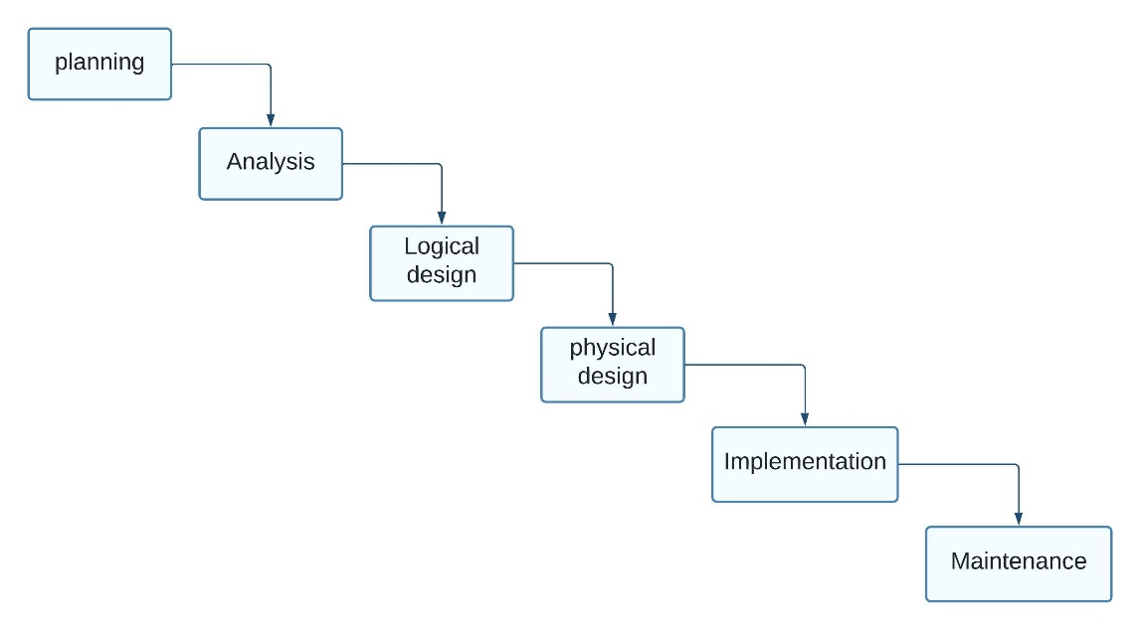

Figure 3‑1 Waterfall model

### Requirement Analysis

This system needed to fulfill following functional and non-functional requirements:

#### Functional requirements

* Admin can add update and delete data of the website.
* User can search for desired category of news.
* A normal device with proper internet connection can access to this website.
* User will redirect to user side and admin will redirect to admin dashboard after login.

#### Non-functional requirements

* Availability: User can access website from anywhere they want with the help of internet.
* Reliability: This site can provide reliable data to user without any additional unwanted data.
* Performance: This site is lightweight and can perform well even in low end devices.
* Portability: This site can be accessed on any device having internet connection.

### Feasibility Analysis

#### Technical Feasibility

In order to design this system, it uses off-self and existing technologies, software and hardware so there is no technological hurdle to build this system. The software and hardware requirements for the development of this project are not many and are already available as free as open source.

#### Economic Feasibility

The system is economically feasible as it doesn’t require any addition hardware and software. Since the interface for this system is developed using existing resources and technologies available in open source. There is nominal expenditure and economic feasibility for certain.

#### Operational Feasibility

The system, will handles the request in a better way and make the process easier thus, it is sure that the system developed is operationally feasibility because both administrators and user can easily adopt the environment of the project and do their task without any issue.

### Data Modelling (ER-Diagram)

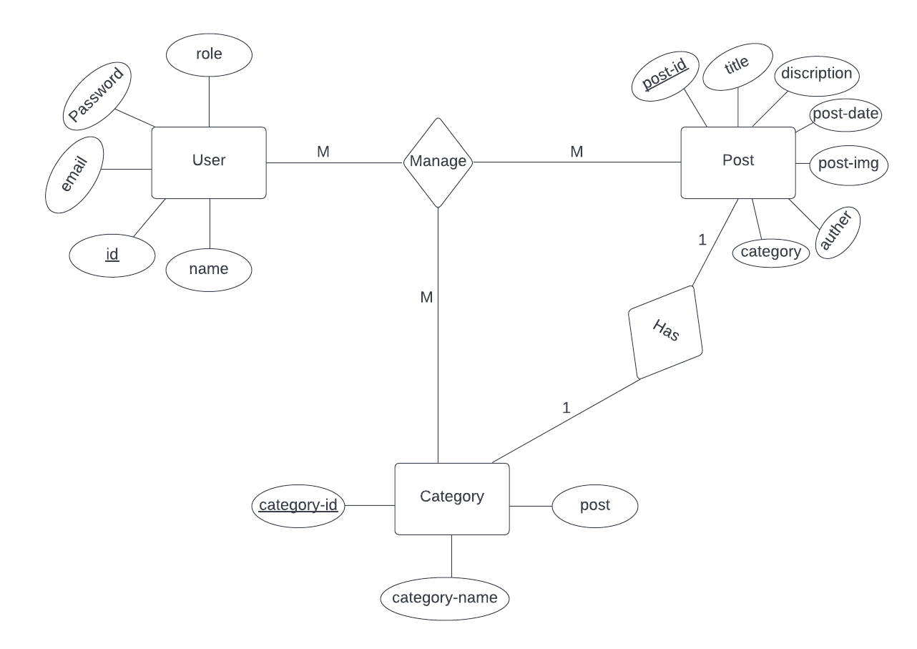

Figure 3‑2 ER diagram of online news portal

### Process Modelling (DFD)

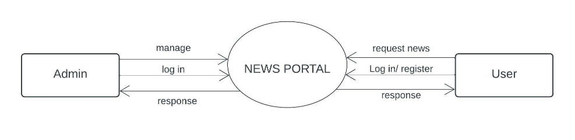

Figure 3‑3 Zero Level DFD of Online news portal

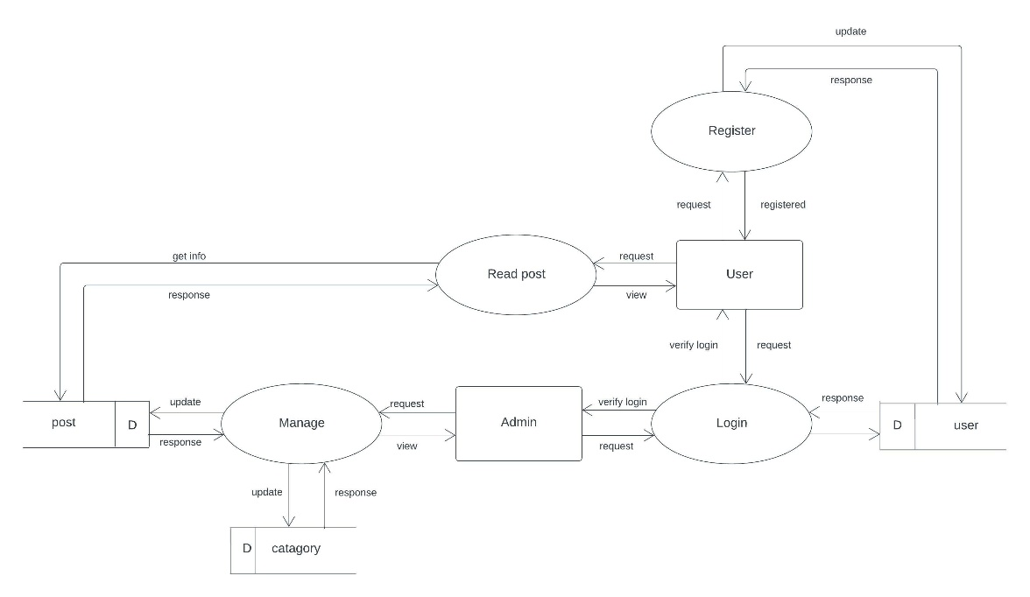

Figure 3‑4 One level DFD of Online news portal

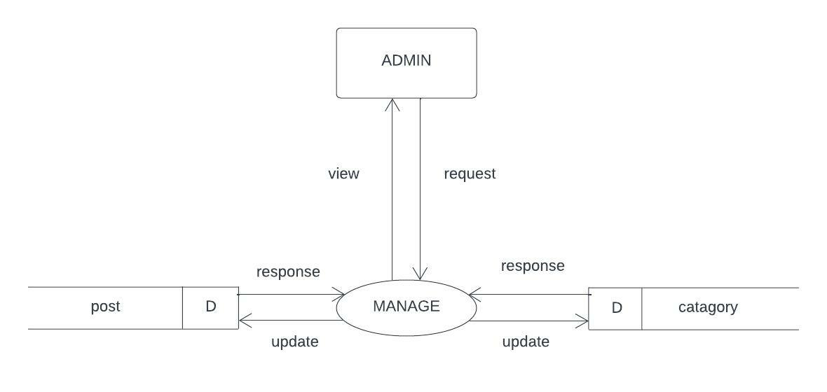

Figure 3‑5 Two level DFD of Online news portal

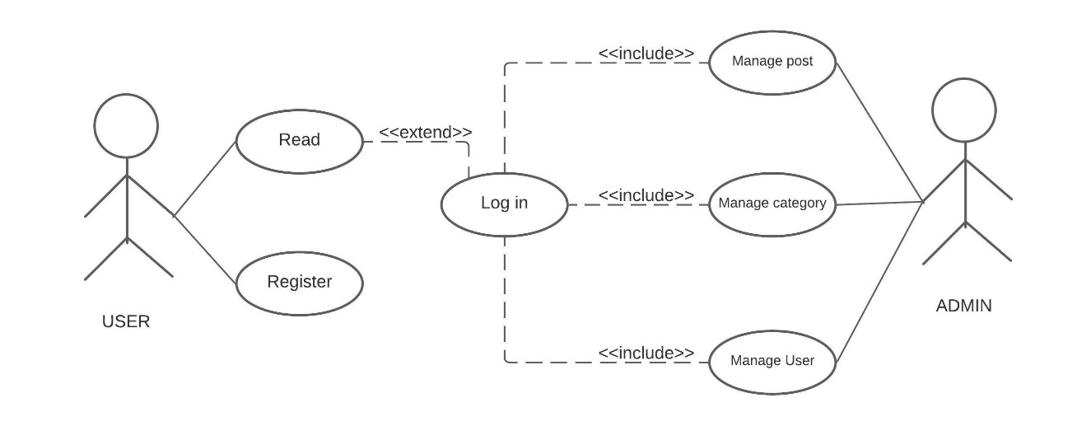

Figure 3‑6 Use case Diagram of Online news portal

## System Design

Here we represent overall concept of how our system will work. In our system there are two sides. They are the admin and the user/reader, the admin role is to manage all the post/news detail as well as user details on system while the user can read the published news on the site according to there want and user can search for the required news details [4].

### Architectural Design

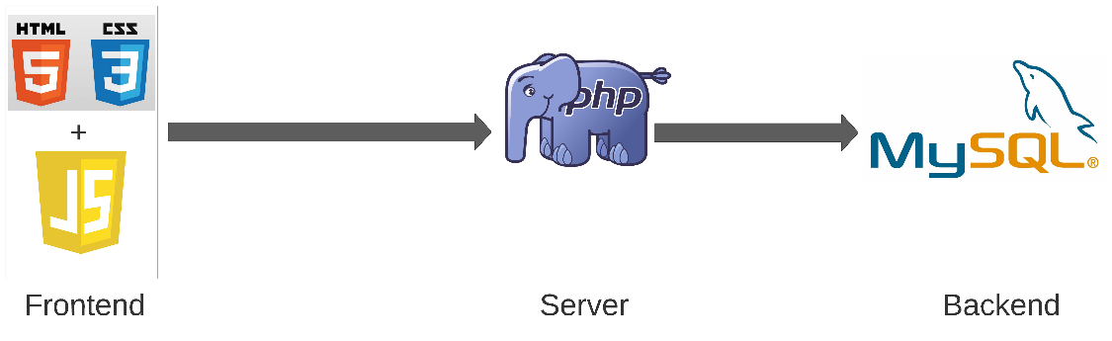

Figure 3‑7 Architecture design of Online news portal

### Database schema design

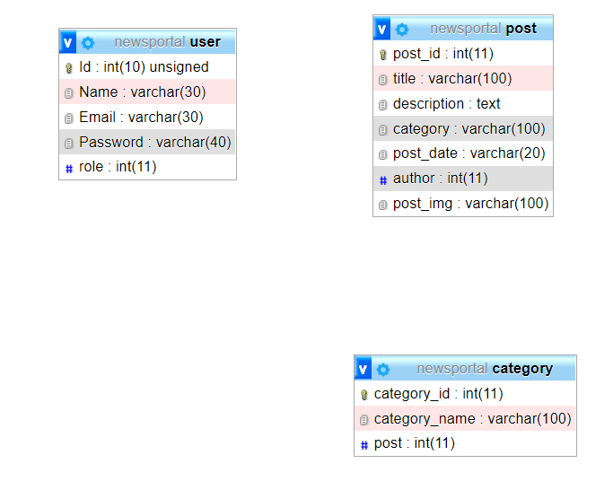

#### Data Dictionary

Table 3‑1 User Table

|  |  |  |  |  |  |  |
| --- | --- | --- | --- | --- | --- | --- |
| id | Name | Type | Size | Not null | Dflt-value | Constrain |
| 1 | Id | Int | 10 | No | None | Primary Key |
| 2 | Name | Varchar | 30 | No | None |  |
| 3 | Email | Varchar | 30 | Yes | Null |  |
| 4 | Password | Varchar | 40 | Yes | Null |  |
| 5 | Role | Int | 11 | No | None |  |

Table 3‑2 Post Table

|  |  |  |  |  |  |  |
| --- | --- | --- | --- | --- | --- | --- |
| id | Name | Type | Size | Not null | Dflt-value | Constrain |
| 1 | post_id | int | 11 | No | None | Primary Key |
| 2 | title | varchar | 100 | No | None |  |
| 3 | description | text |  | No | None |  |
| 4 | category | varchar | 100 | No | None |  |
| 5 | post_date | Varchar | 50 | No | None |  |
| 6 | auther | int | 11 | No | None |  |
| 7 | post_img | varchar | 100 | No | none |  |
|  |  |  |  |  |  |  |

Table 3‑3 Category Table

|  |  |  |  |  |  |  |
| --- | --- | --- | --- | --- | --- | --- |
| id | Name | Type | Size | Not null | Dflt -value | constrain |
| 1 | category_id | Int | 11 | No | None | Primary key |
| 2 | category_name | varchar | 100 | No | None |  |
| 3 | post | int | 11 | No | 0 |  |

### Interface Design

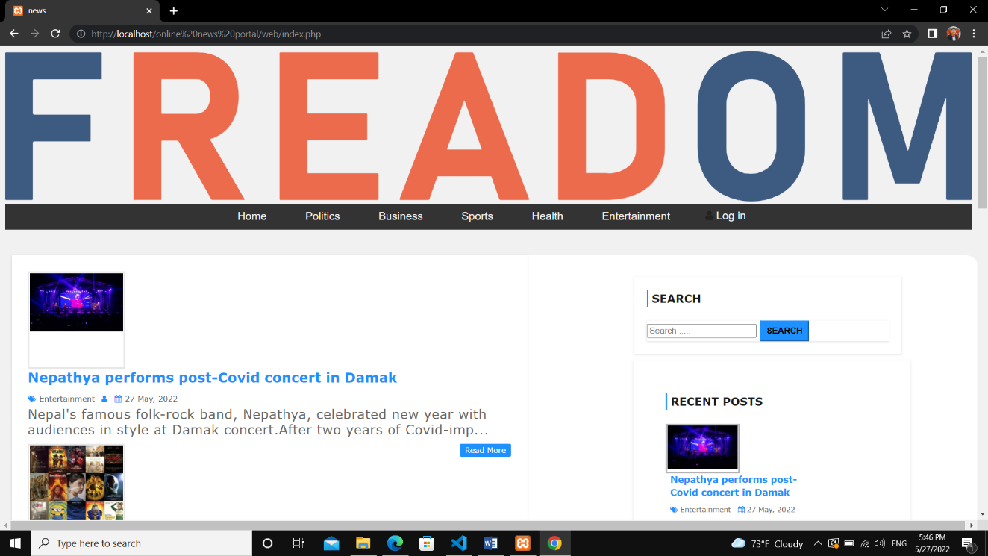

Figure 3‑8 Home Page

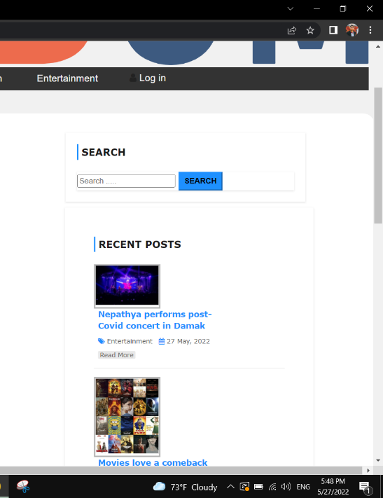

Figure 3‑9 Search Bar and Recent post

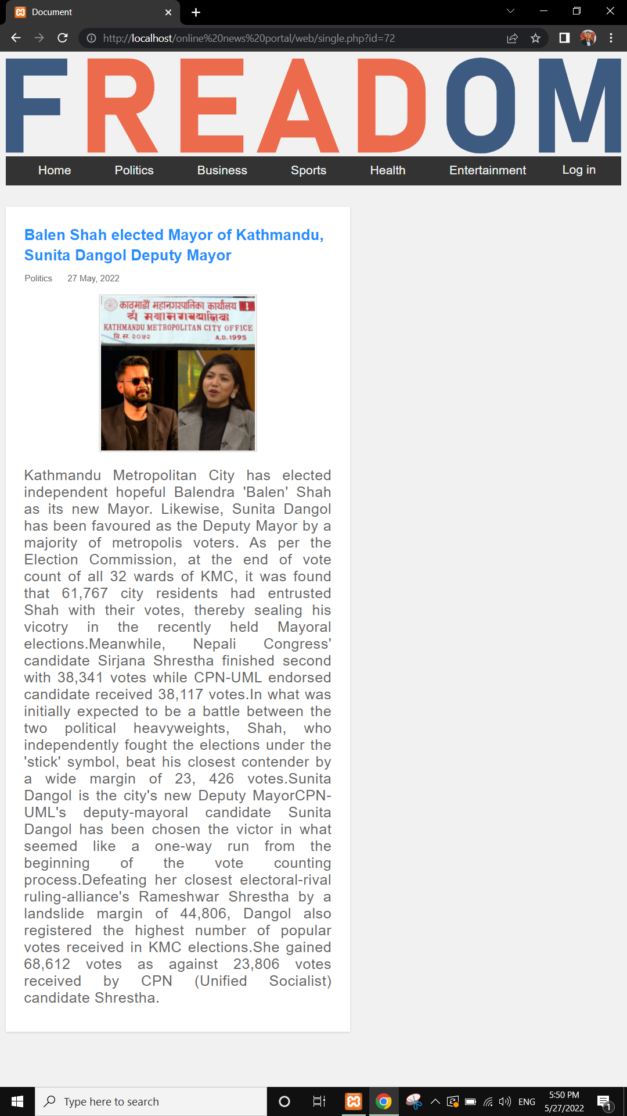

Figure 3‑10 Single news page

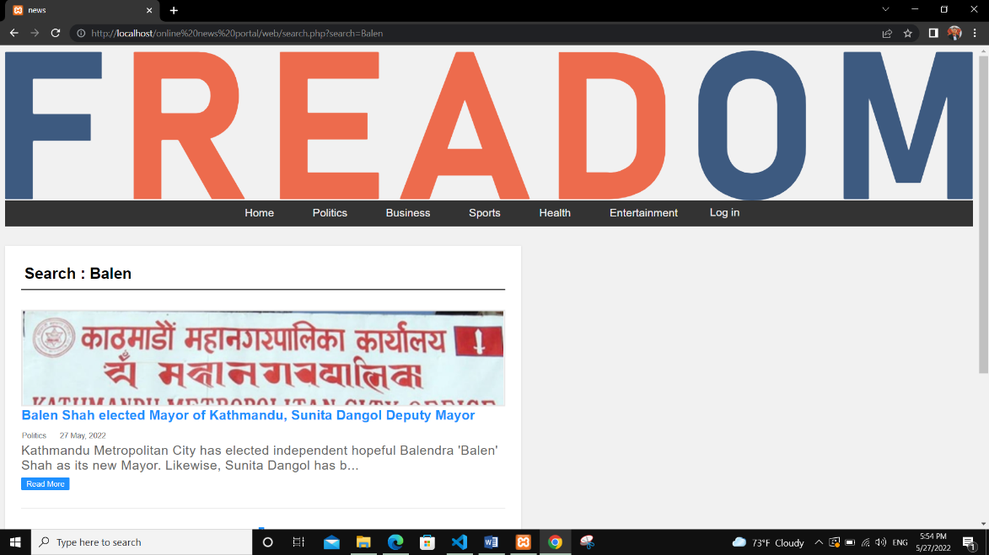

Figure 3‑11 Search result page

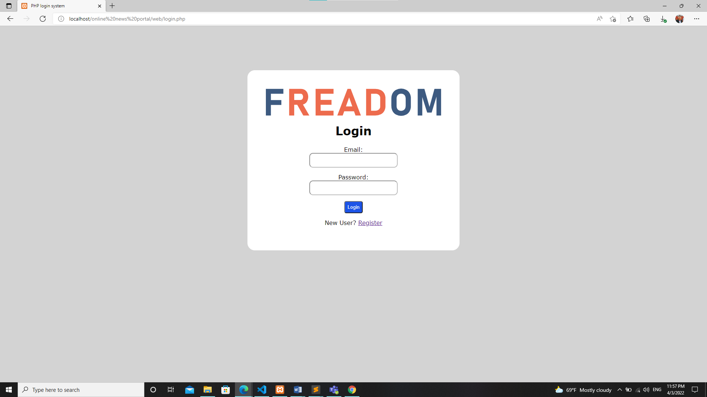

Figure 3‑12 Log in page

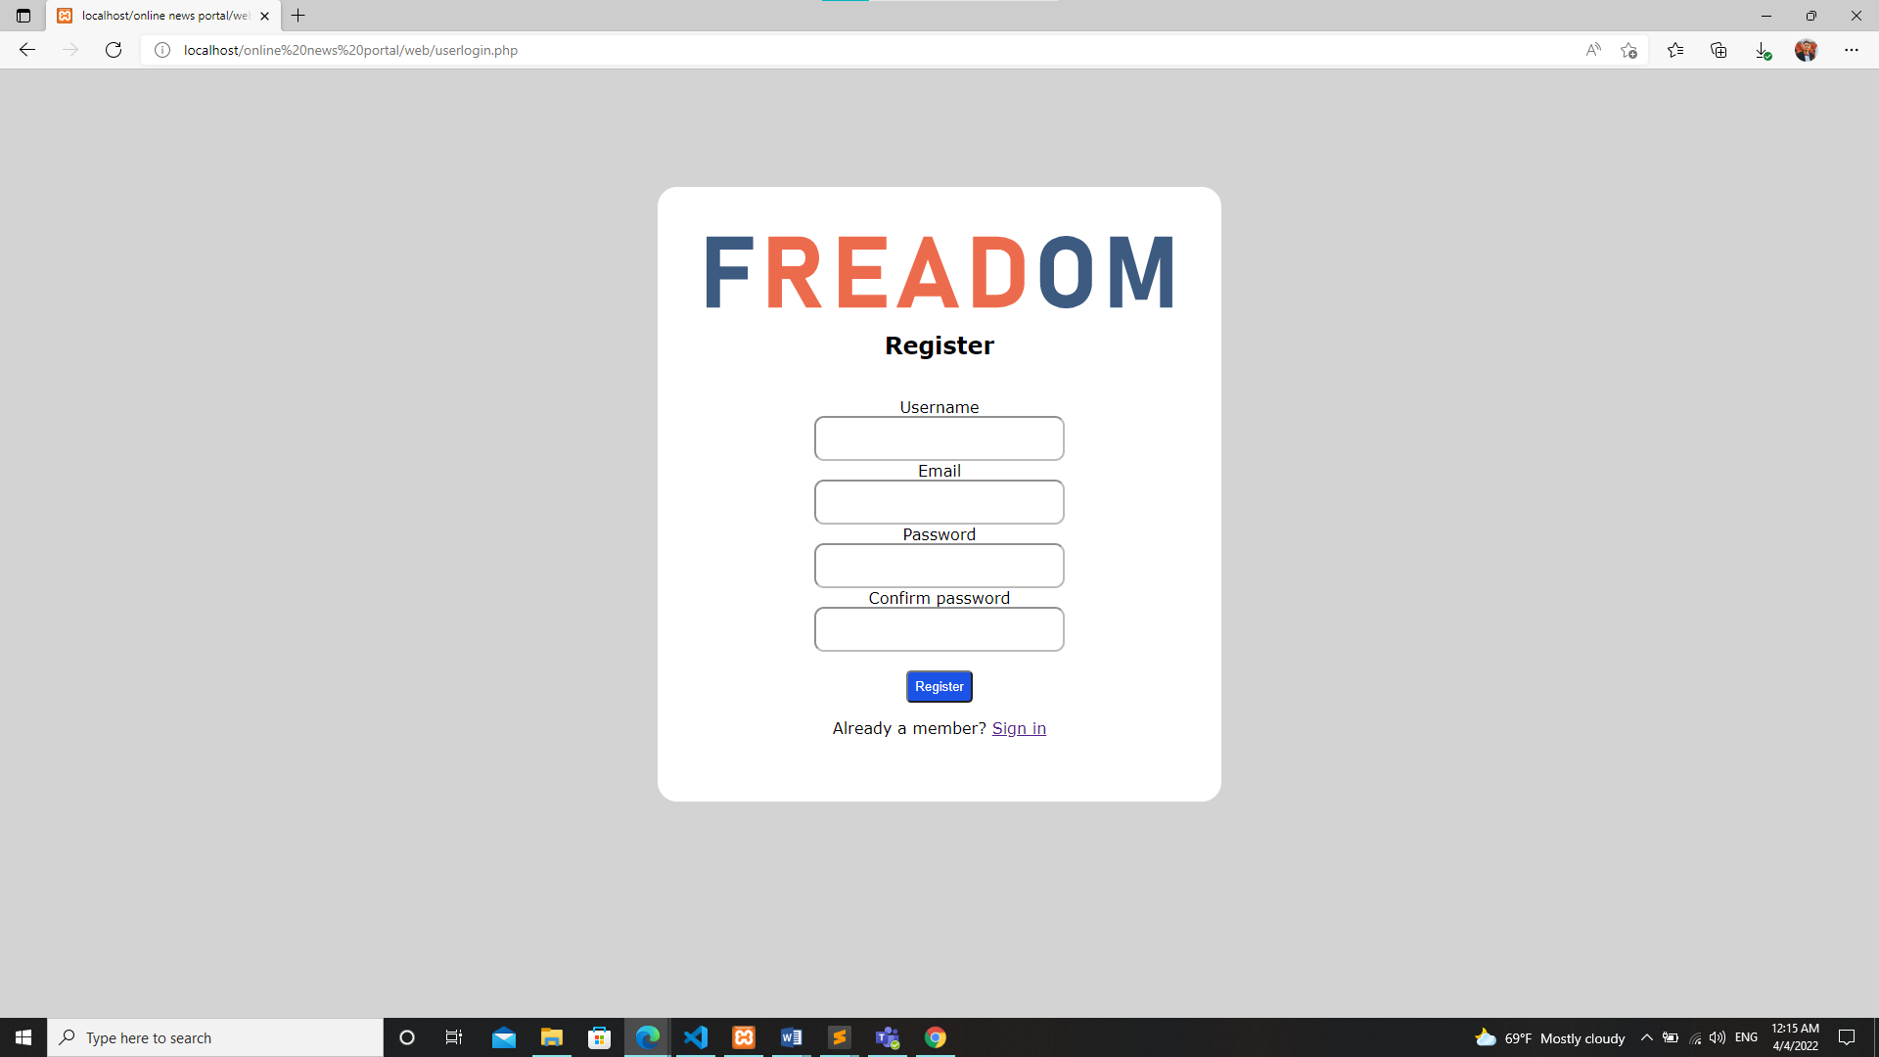

Figure 3‑13 Register page

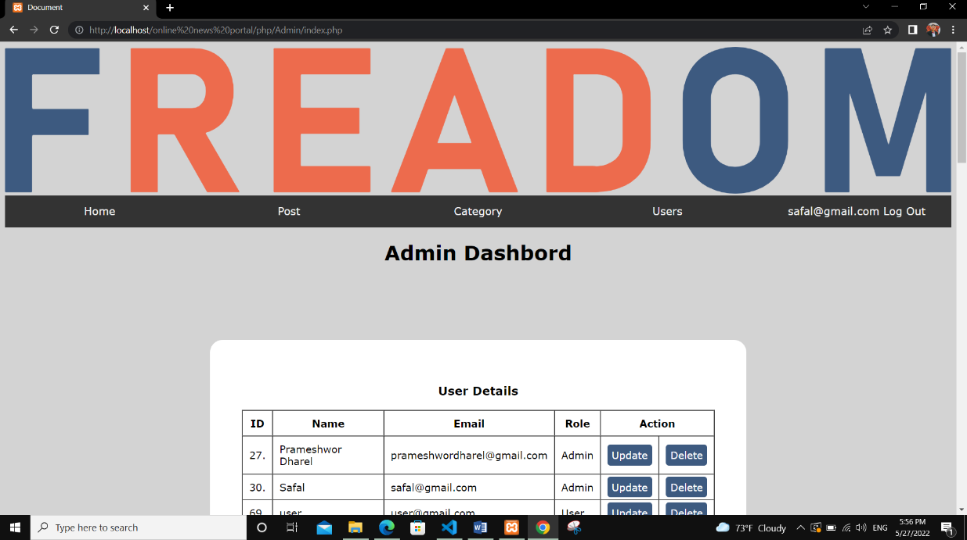

Figure 3‑14 Admin Dashboard

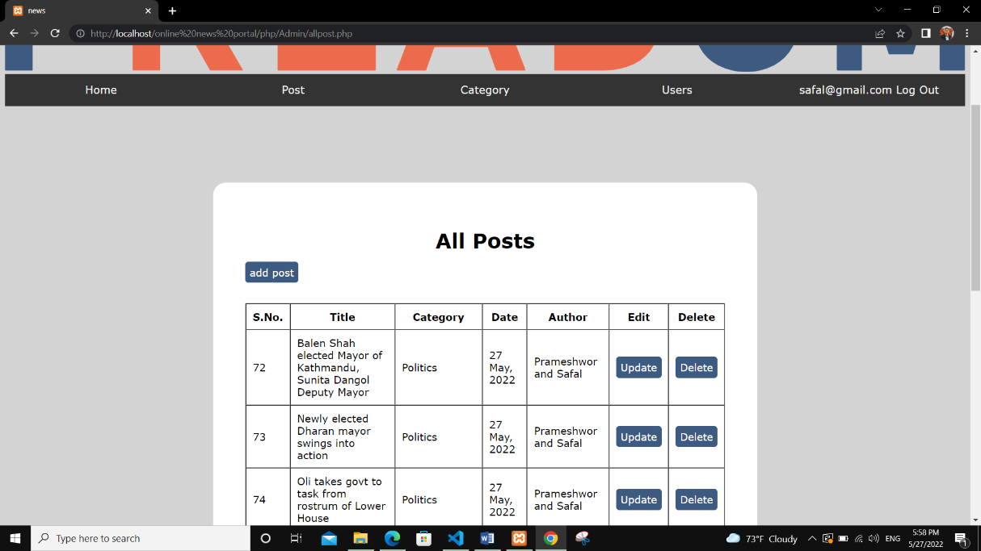

Figure 3‑15 Post page

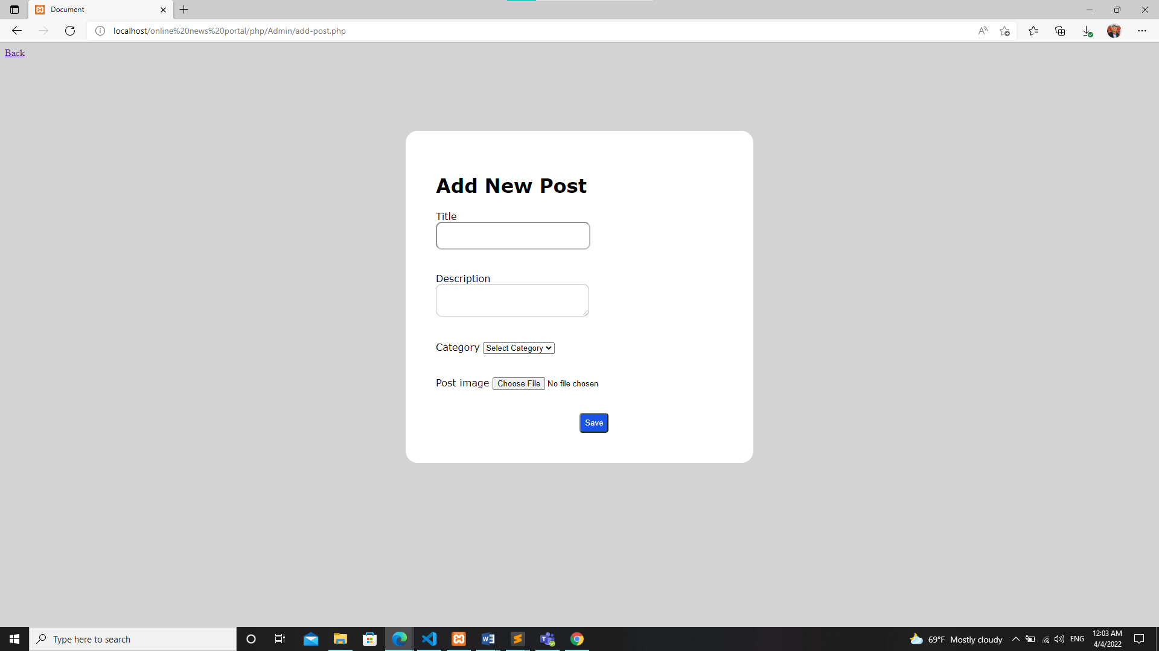

Figure 3‑16 Add post

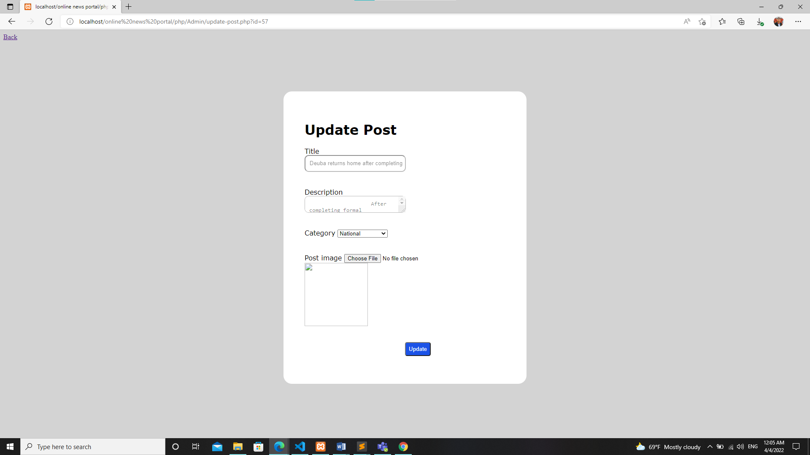

Figure 3‑17 Update Post

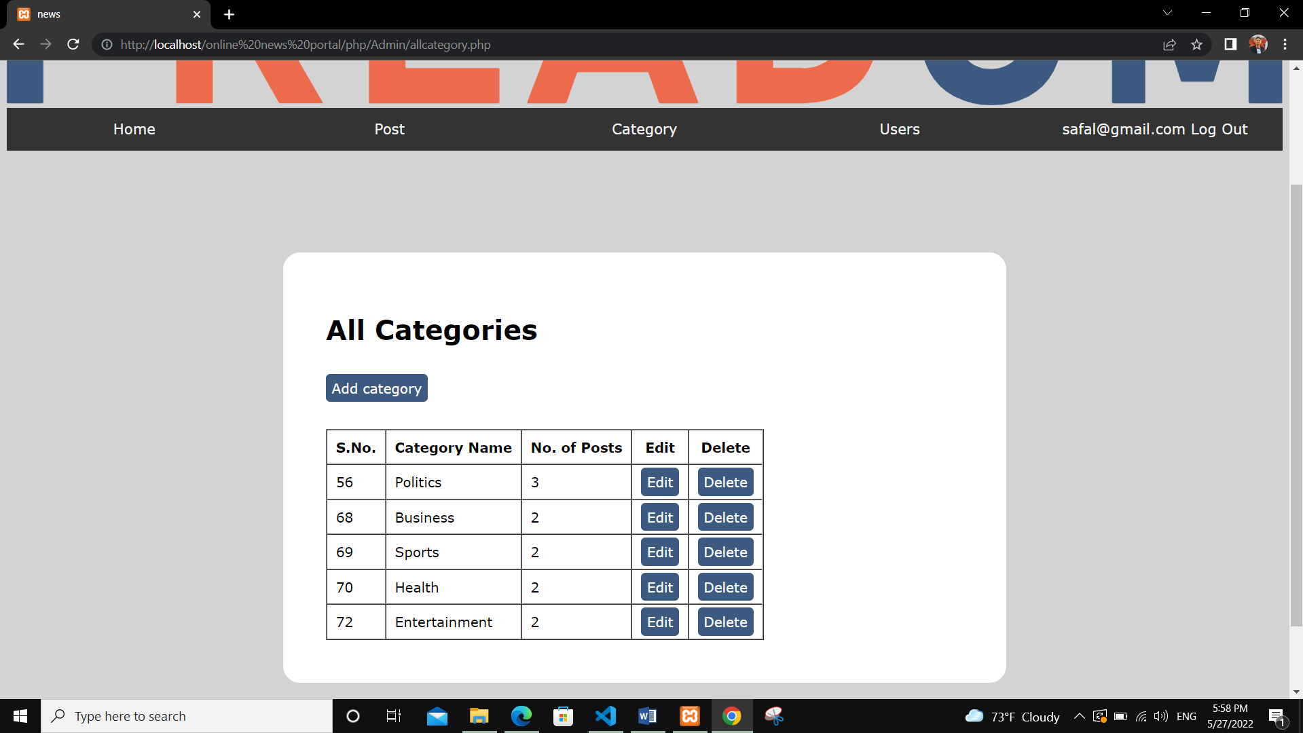

Figure 3‑18 Categories

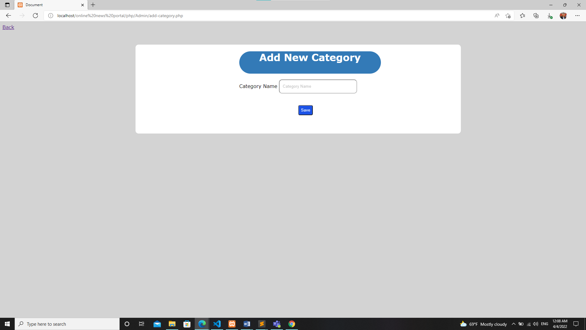

Figure 3‑19 Add categories

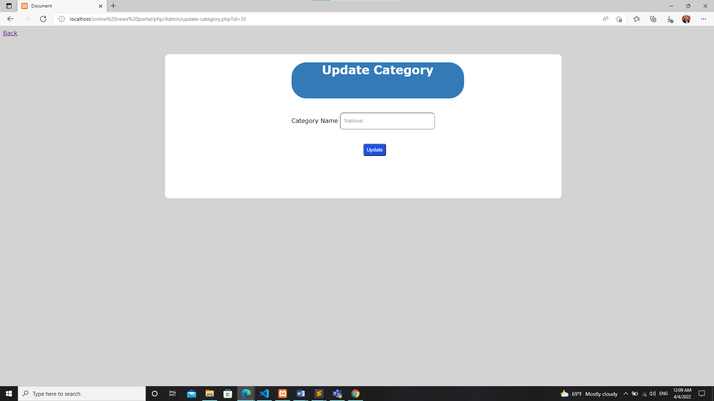

Figure 3‑20 Update Category

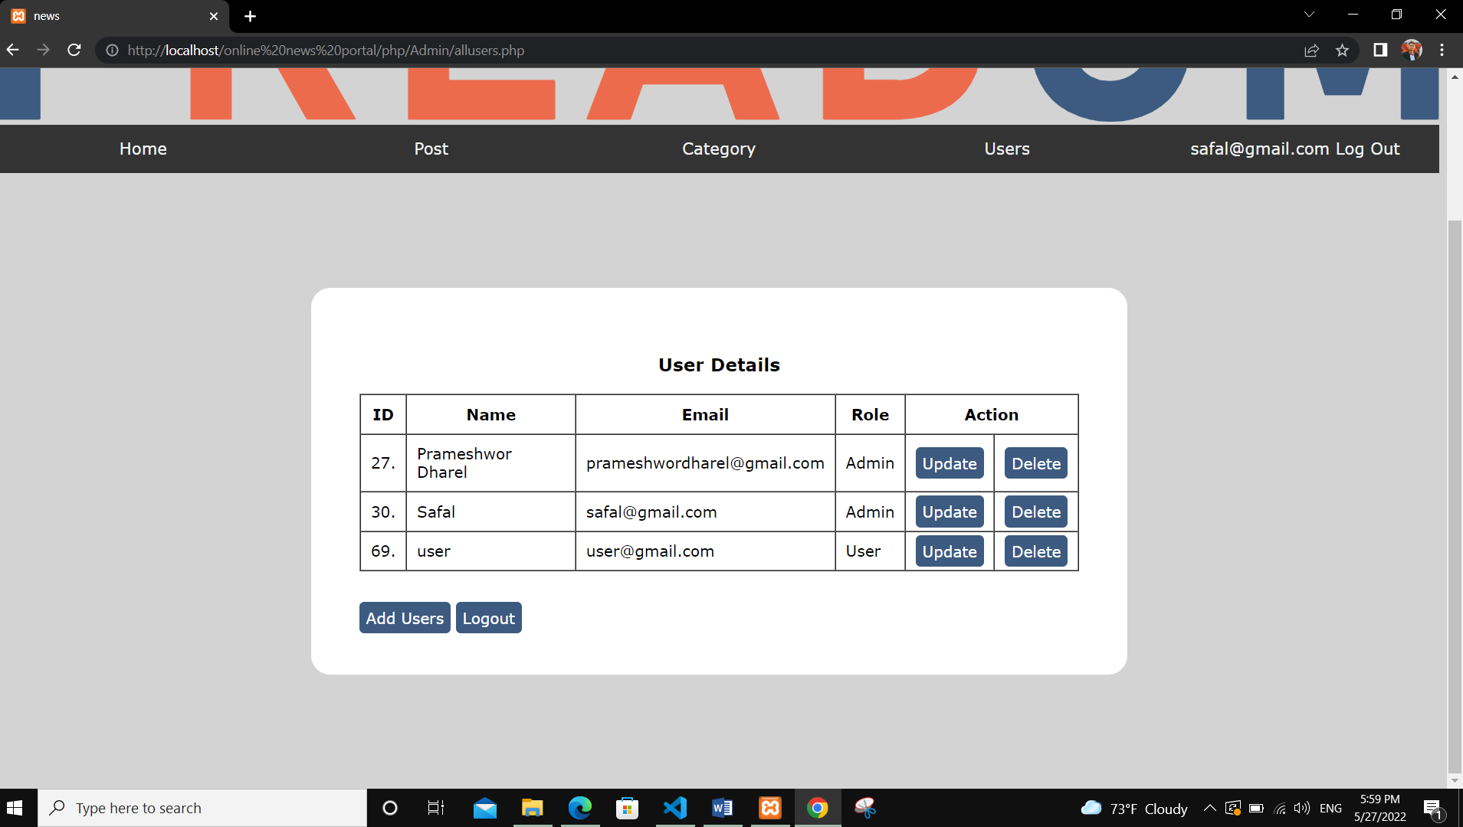

Figure 3‑21 Users details page

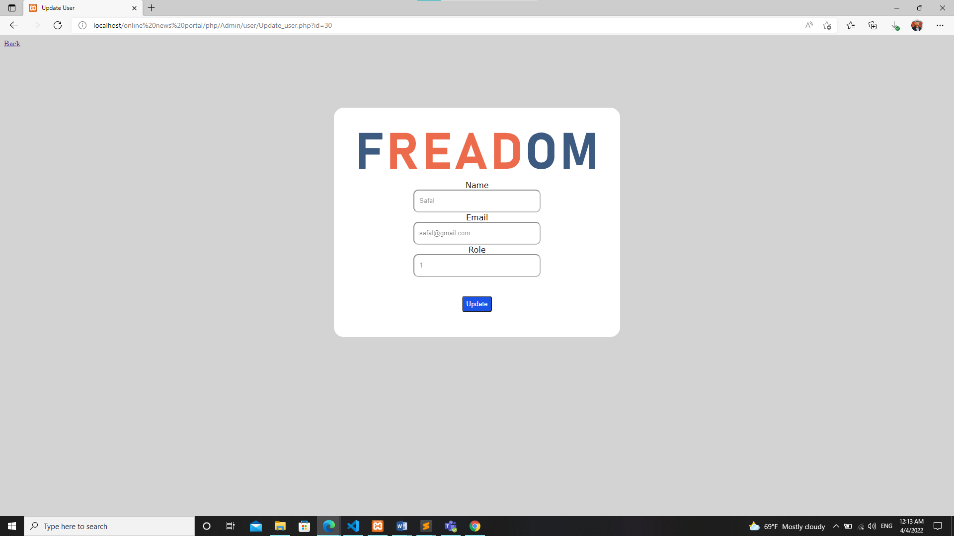

Figure 3‑22 Update users detail page

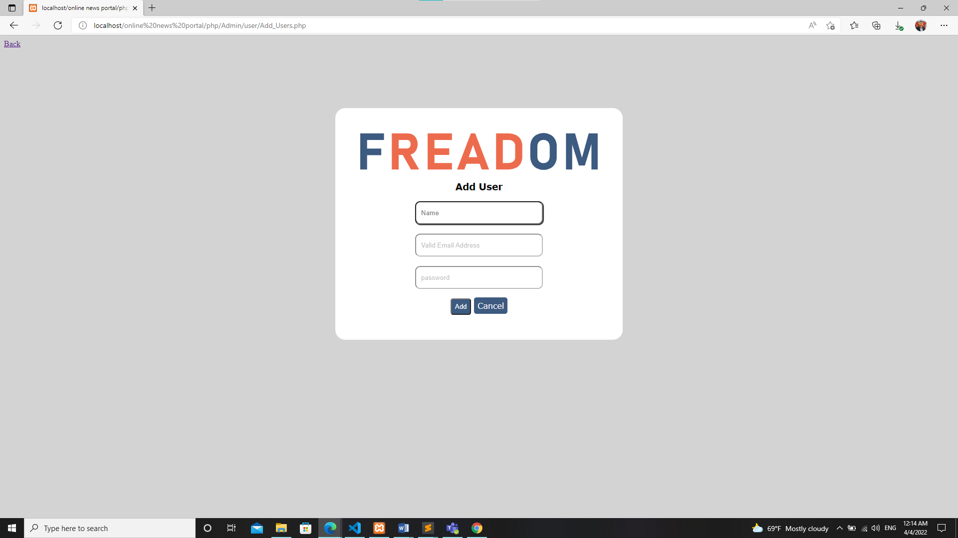

Figure 3‑23 Add user page

# Implementation and Testing

## Implementation

### Tools Used

Xampp Server: XAMPP is a free and open-source cross-platform web server solution stack package developed by Apache Friends, consisting mainly of the Apache HTTP Server, MariaDB database, and interpreters for scripts written in the PHP and Perl programming languages.

PHP: Hypertext Preprocessor, is a widely used, general-purpose scripting language that was originally designed for web development, to produce dynamic web pages. It can be embedded into HTML and generally runs on a web server, which needs to be configured to process PHP code and create web page content from it.

MySQL: MySQL is easy to use, yet extremely powerful, secure, and scalable. And because of its small size and speed, it is the ideal database solution for Web sites.

HTML & CSS: HTML code ensures the proper formatting of text and images and CSS helps for better look of the website.

JavaScript: JavaScript is used to enhance HTML pages and is commonly found embedded in HTML code.

Online editor tools: we create ER and DFD using https://lucid.co/ online editor.

Platform: Microsoft Visual studio code is the IDE which was used during project development period.

### Implementation Details of Modules

#### Admin Module

Admin can have access to login and add or create new Post and Post category and also can view and manage all users list. Moreover, admin also can manage the data on the site through admin panel and change them if needed.

#### User Model

In this module normal user can read all the news posted on the site by admins or author. User can have their own account too.

#### Post Module

In this module admin can add new post as well as modify them which include editing, and deleting of post.

## Testing

The overall aim for testing a system is to ensure that the system meets its entire functional requirement and to check its performance. The accuracy of the program can be tested with some varying data, testing gives assurance that the new system will achieve its objectives and purpose. Testing is basically an attempt of executing program to find bugs. It consists of various types for which a system is subjected to but the ones to be carried out are the testing objectives. The test plan presents the test in details through identifying the test case areas within the system [5].

### Test case for unit testing

Unit testing is a type of software testing where individual units or components of software are tested. The purpose is to validate that each unit of the software code performs as expected. Unit testing is done during the development (coding phase) of an application by the developers. Unit Tests isolate a section of code and verify its correctness.

Each and every component of this “FREADOM News” website have been tested individually by different components which has been shown in the table below. We have tested each component and manipulating each and every kind of input and checking the corresponding output until the components is working effectively and correctly.

### Test case for system testing

System testing is a level of testing that validates the complete and fully integrated software product. In software testing the behavior of whole system is tested as defined by the scope of the developed project. It is the most of the final test top verify that the system to be delivered meets the specification and purpose. System testing should focus on testing interactions between the components and objects that make up a system as well as test the reusable components or system to check that they work as expected when they integrated with new components [6].

Table 4‑1 Testing Reports

|  |  |  |  |  |  |  |
| --- | --- | --- | --- | --- | --- | --- |
| Test Case | Test Case | Test Steps | Test Date | Expected Results | Actual Result | Pass/ Fail |
| TC01 | Check the login module with correct input access the system | 1.Go to site [http://localhost/online news portal/web/userlogin.php](http://localhost/online%20news%20portal/web/userlogin.php)  2. Enter valid  3.Enter password  4.Click login | email= [safal@gmail.com](mailto:safal@gmail.com)  Password=123456 | Allow the admin login to the admin management system. | The admin logged into the system. | Pass |
| TC02 | Check the login module with incorrect input access the system | 1.Go to site [http://localhost/online news portal/web/login.php](http://localhost/online%20news%20portal/web/login.php)  2.Enter email  3.Enter password  4.Click login | Username= [safal@gmail.com](mailto:safal@gmail.com)  Password=admin | Deny the admin access to the admin management system. | The admin was unable to login into the system. Error message incorrect username or password. | Pass |
| TC03 | This test the Add user record with correct input | 1. Go to site http://localhost/online news porta/php/Admin/user/Add_Users.php  2.Enter users Name, Email, Password. | Username: Prameshwor Dharel  Email ID: [Prameshwor@gmail.com](mailto:Prameshwor@gmail.com)  Password=123456  Confirm password= 123456 | Allow the admin to save into the record | The admin saved into the record of the donor and will be update | Pass |
| TC04 | This test the Add user record with correct input | 1. Go to site http://localhost/online news porta/php/Admin/user/Add_Users.php  2.Enter users Name, Email, Password. | Username: Prameshwor Dharel  Email ID: [Prameshworgmailcom](mailto:Prameshwor@gmail.com)  Password=123456  Confirm password= 123456 | Prompt an error “Please include an '@' in the email address. 'theneerajpa nditgmail.co m' is missing an '@'.” | The admin doesn’t save into the donor record. | Pass |
| TC05 | This test the update Admin details with correct input. | 1.Go to site <http://localhost/online> news portal/php/Admin/user/Update_user.php  2.Click on Account and select Update option.  3.Enter the value which you want to change which you want to change.  4.Click Update | Current name: kaka  New name: Hari | Allow the admin to update password | SUCCES S:Your Name succesfull y changed. | Pass |

# Conclusion and Future Recommendations

## Lesson Learnt / Outcome

After the completion of this project we are expecting fallowing output will minimized problems:

* Deliver quality news to the user.
* Remove confusions.
* UpToDate news delivery
* Expected to be efficient in terms of time.
* Ensure Customer satisfactions etc.

## Conclusion

FREADOM project is a web-based application. The aim of this project is to provide quality news to the user and allow them to search desired news themselves. Software works as the mean to provide actual information to the public. The main purpose of this project is to save time for everyone wants to read news fast. People don’t need to buy paper newspaper when they will get news on their computer and laptop anytime and anywhere. At the end, It has been great pleasure for me to get opportunity to work on this challenging project by using PHP, JavaScript & MySQL.

## Future Recommendations

Software building is never ending process and continues the life of the software as per the changing needs of the user from time to time. There might be many reasons for updating software some of them are customer may face different problem in website like page refresh every time when they submit the form or try to change something and that may not satisfy the customer. Due to shortage of time, we become unable to include many others things.

Following are some missing features on this site which can be added in future:

* Video attachments while uploading an article.
* Proper feedback system.
* Notification alerts is not enabled now.

References

|  |  |
| --- | --- |
| [1] | "News Portal Project report," [Online]. Available: https://pdfcoffee.com/news-portal-project-report-pdf-free.html. |
| [2] | "Project Report of Online News Portal," [Online]. Available: https://pdfcoffee.com/project-report-of-online-news-portal-pdf-free.html. |
| [3] | G. &. V. Hoffer, Modern Systems Analysis and Design, 8th Editio, Joey F. George,Joseph S Valacich,, 2017. |
| [4] | I. Sommerville, SOFTWARE ENGINEERING, Pearson Education, Inc.,, 2011. |
| [5] | "System Testing," GeeksForGeeks, [Online]. Available: https://www.geeksforgeeks.org/system-testing/. [Accessed 27 05 2022]. |
| [6] | S. Jaiswal, "System Testing," javatpoint, [Online]. Available: https://www.javatpoint.com/system-testing. [Accessed 27 05 2022].  News were copied from following websites: https://thehimalayantimes.com, edition.cnn.com, www.nepalnews.com, english.onlinekhabar.com. |